

String Based Programs (1-14)

Date: 11/03/2026

Name: M. Sahasra
Reg. No.: 192425317
Course Code: CSA0919
Course Name: Programming in Java for Spring Framework
Faculty Name: Dr. Magesh Kumar

1. Find Frequency of Characters in a String

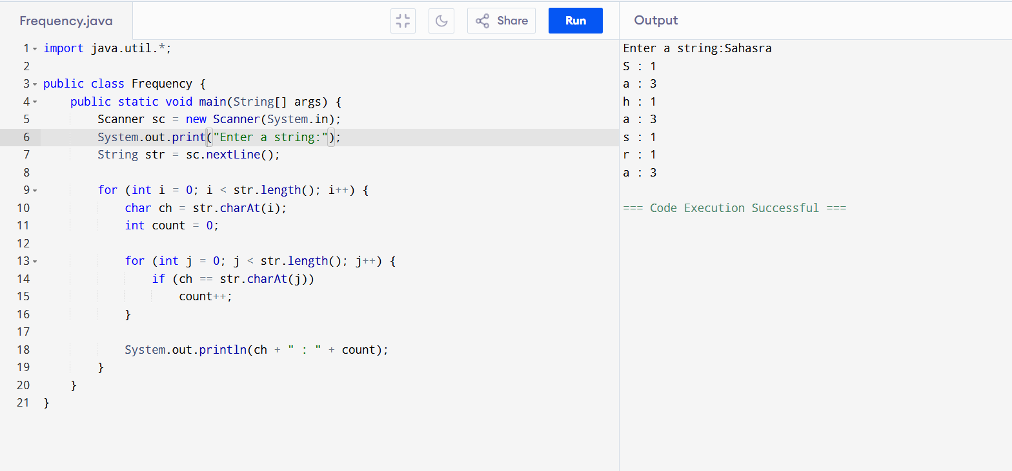
2. Find Length of String
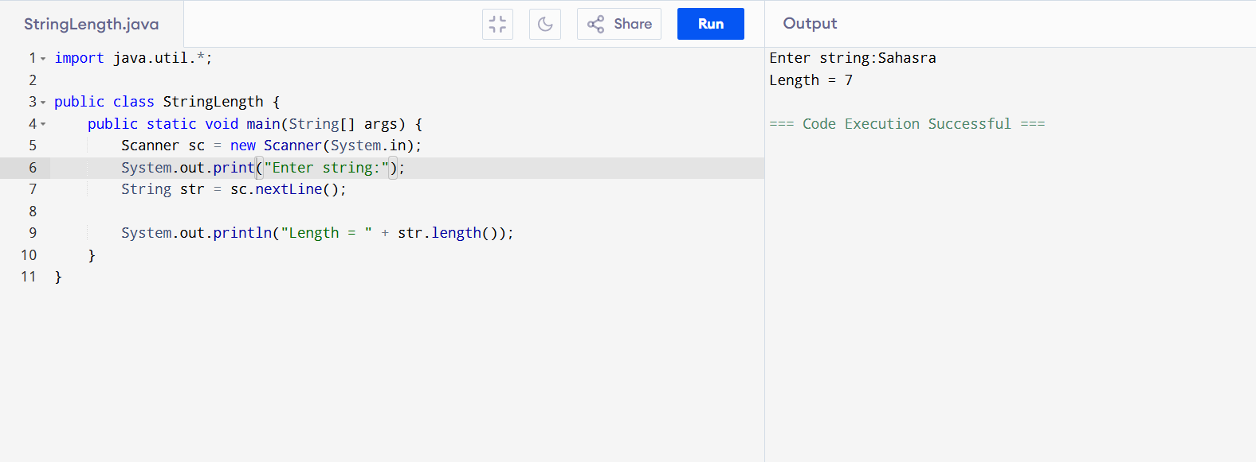

3. Compare Two Strings
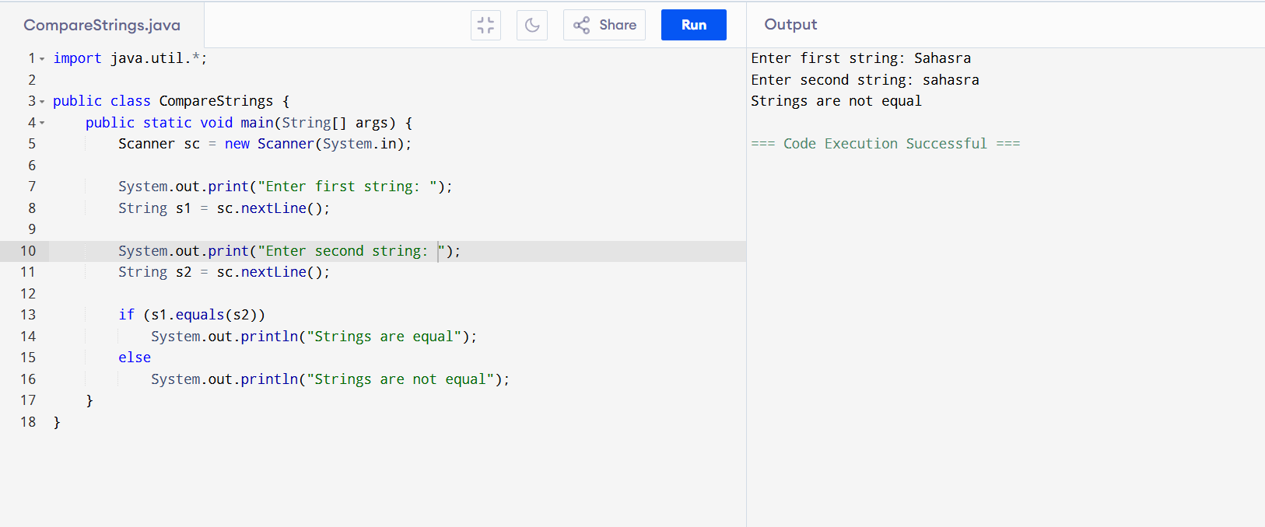

4. Reverse a String
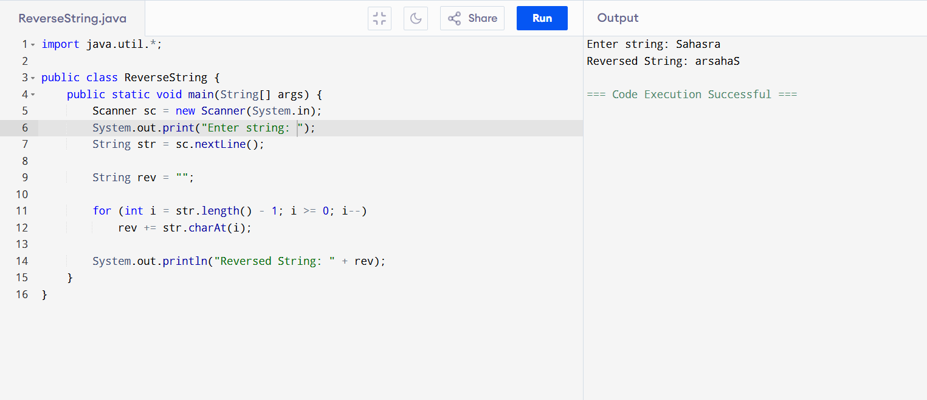
5. Concatenate Two Strings
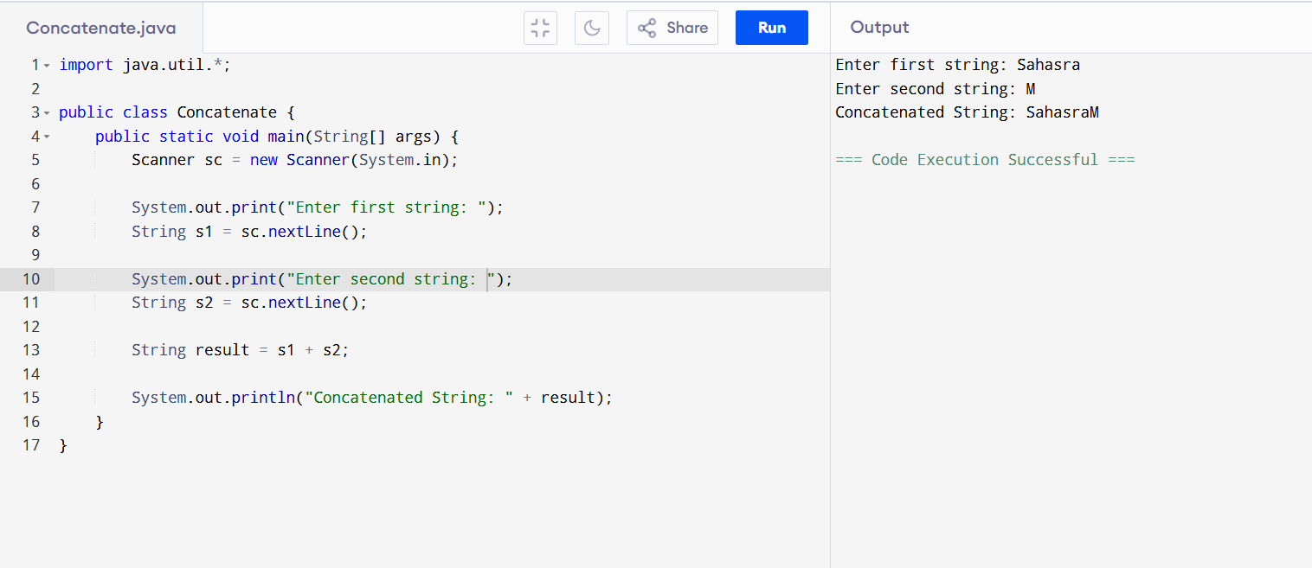
6. Copy String into Another String
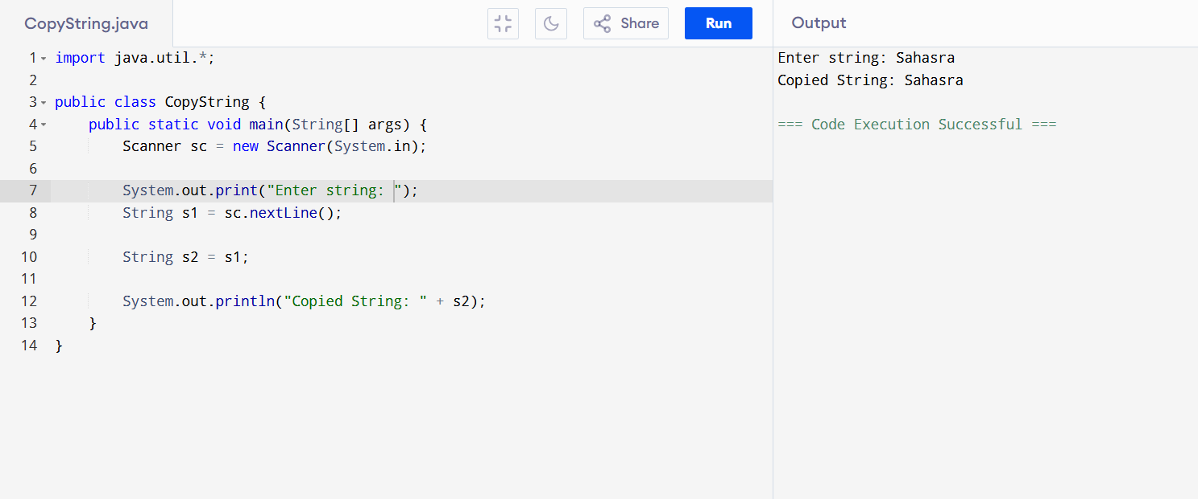
7. Count Vowels, Consonants, Digits, Spaces
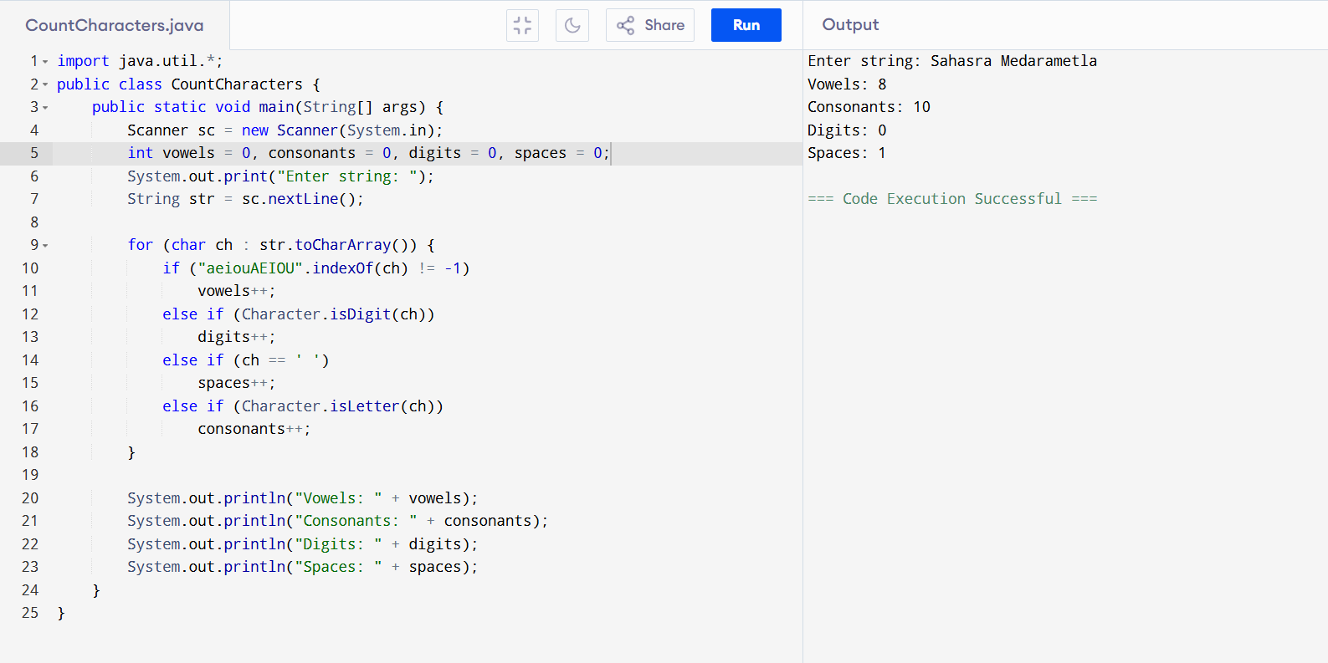
8. Check Character Type
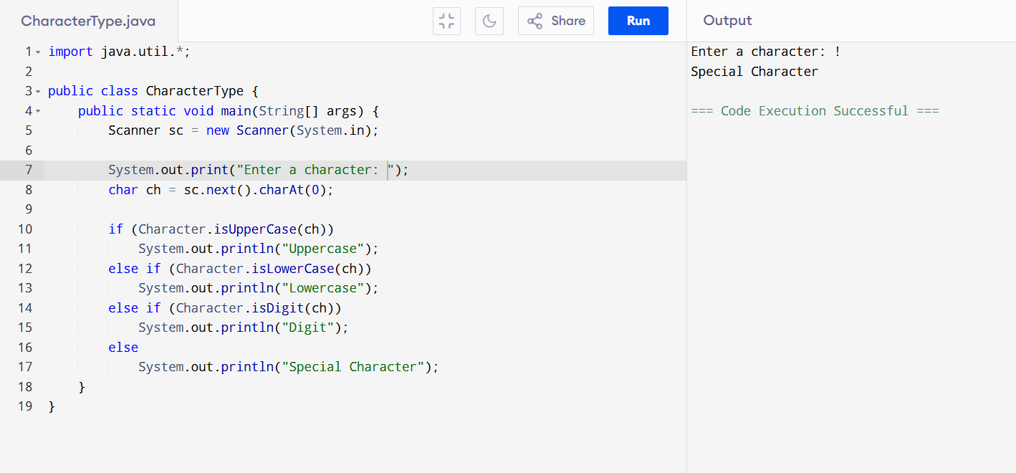
9. Sort Elements in Lexicographical Order
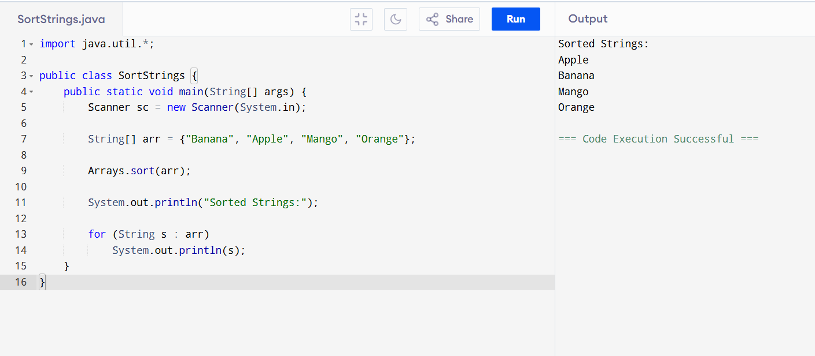
10. Swap Two Strings
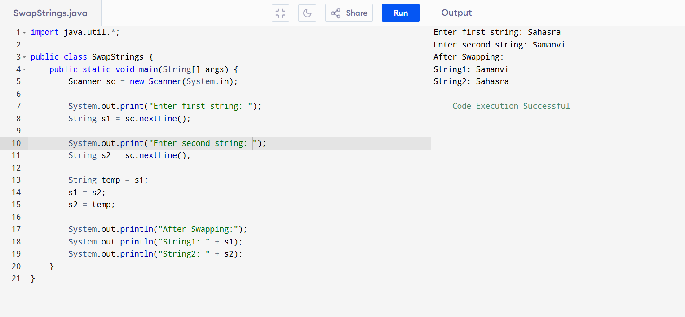
11. Count Words in a String
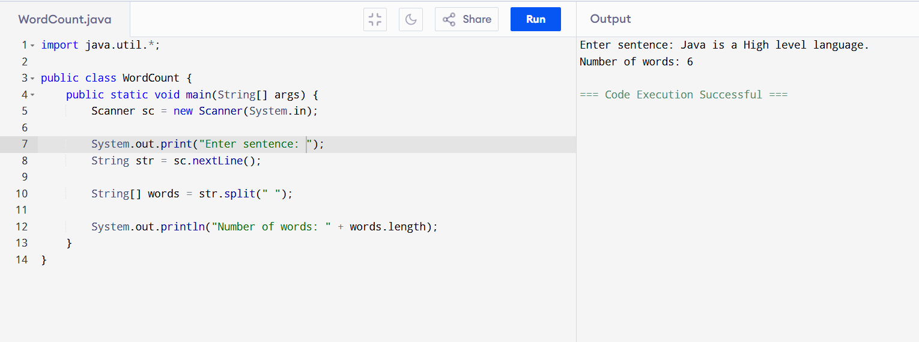
12. Find Substring in String
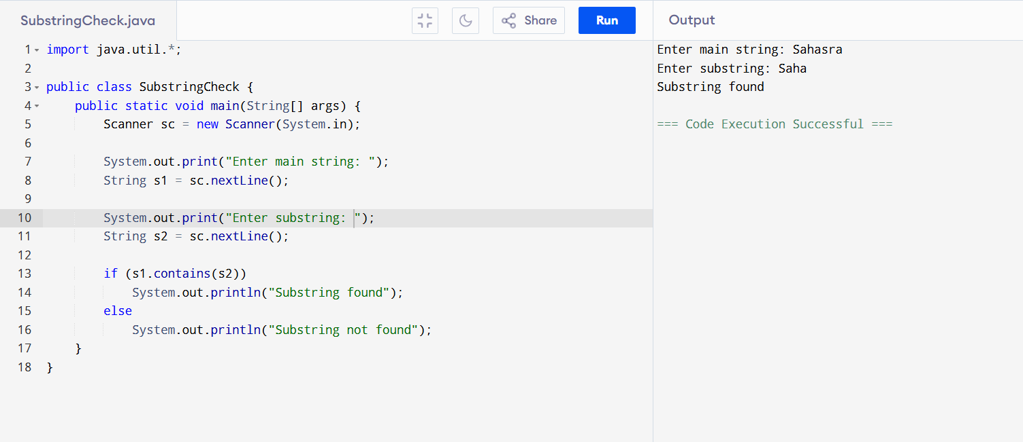
13. Check String Palindrome
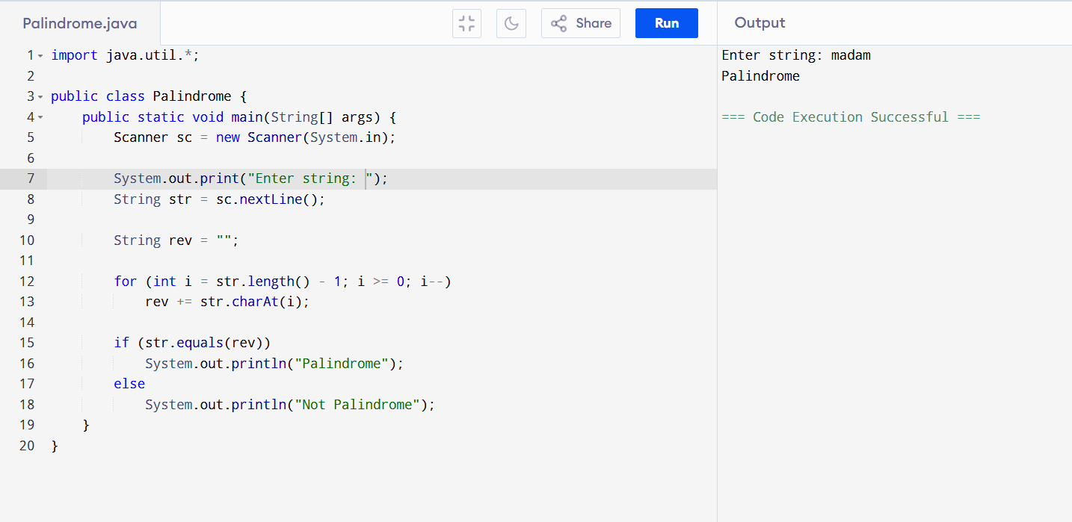
14. Check Vowel or Consonant
